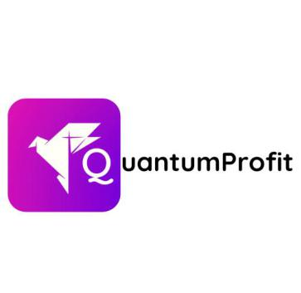

**OT (OVERNIGHT TRADE CHARGES) BREAKDOWN**

Hello Daniel sjöstedt

I hope this message finds you well. You’re receiving this message due to the fact your OT charge deposits have been received, But you still have an outstanding balance payment of $300 before withdrawals can be completed fully, Due this reasons your withdrawal will be on hold. This charges are required in other to process your withdrawal request.

**OT CHARGES :** This are charges incurred when a trade or position has been left overnight for weeks/months without been terminated aor withdrawn [Read More](https://www.investopedia.com/terms/o/overnight-position.asp)

|  |  |  |  |
| --- | --- | --- | --- |
| **OT BREAKDOWN** |  |  |  |
|  |  |  |  |
| **Date** | **Total Deposits** | **Earnings** | **OT Charges** |
|  |  |  |  |
| 10/7/2023 | **$**852 | **$4422** | **4422 x 27%** |
|  |  |  |  |
|  |  |  | **$ 1200.00** |
|  |  |  |  |
| 26/2/204 | **$600** |  | **$ 600 Paid** |
| 26/2/204 | **$300** |  | **$ 300 Paid** |

|  |
| --- |
| **$ 300 Reminder** |

Feel free to reach out to me on my socials.

Whatsapp: [https://wa.me/+1 (555) 055-7080](https:/wa.me/+1 (555) 055-7080) ,

Telegram: <https://t.me/barbie_brooke>,

Company Website: <https://www.quantumprofits.co.uk/home>.

Best regards

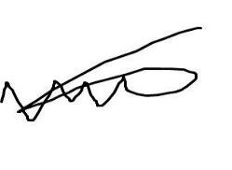

Brooke Harris

Super Administration Officer

+1 (555) 055-7080